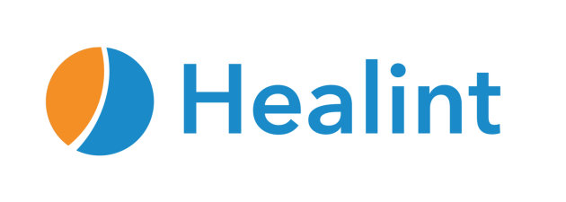

Healint Company Fact Sheet
Company Healint

Headquarters Singapore, Asia

Description Healint helps the one billion people who suffer from migraine and other neurological conditions. The company is the developer of the world's largest migraine tracking and research platform Migraine Buddy©.

Using deep analytics and machine learning, Healint generates real-world evidence for patients, physicians, and researchers to improve treatment outcomes and expedite clinical trials. Healint collaborates with the world's leading scientists to improve the diagnosis, treatment, and lives of patients suffering from multiple neurological conditions.

Users With more than one million registered users worldwide and 100 million migraine days tracked on the platform, Migraine Buddy© is the most popular condition-specific app in the world and a Top 10 medical app in the USA and Europe.

Platform and Solutions Using the platform, patients can log data about their symptoms and identify triggers to better understand their condition, and share the summary with their doctor so they can provide more precise care.

Founded Date 2013

Funding Status Pre-series A

Investors Partech Ventures, Wavemaker Partners, Gree Ventures, National Research Foundation

Leadership Francois Cadiou, Founder, Chief Executive Officer

Scientific Advisors Dr. David Dodick, Mayo Clinic
Dr. Andrew Charles, University of California Los Angeles Health
Dr. Stephen Silberstein, Jefferson University
Dr. Peter Goadsby, University of California San Francisco

Company Website https://www.healint.com/

LinkedIn https://www.linkedin.com/company/healint/

Twitter https://twitter.com/Healint

Media Contact North America:
Lacey Trejo Lacey@Scottpublicrelations.com +1-818-517-7143

Rest of the World:
Susanna Hasenoehrl susanna@healint.com +65 8620 1616

